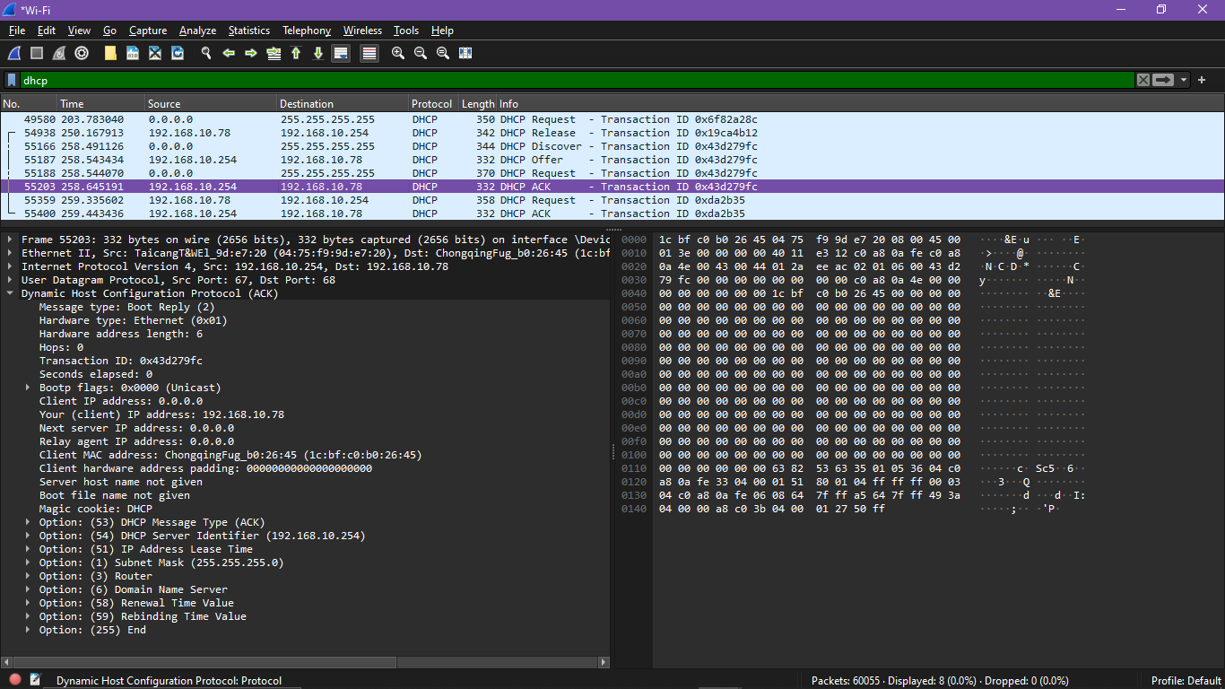
DHCP(Dynamic Host Configuration protocol)

What is DHCP?
DHCP stands for Dynamic Host Configuration Protocol. It simplifies the management of IP addresses in a network by automating the assignment process. Instead of manually configuring each device with an IP address, DHCP allows devices to connect to a network and receive all necessary network information automatically from a DHCP server.

How Does DHCP Work?
DHCP operates based on a client-server model and involves several key steps:
- DHCP Discover: When a device (DHCP client) connects to a network, it sends out a broadcast message (DHCPDISCOVER) to find available DHCP servers.
- DHCP Offer: A DHCP server responds with a DHCPOFFER message, which includes an available IP address and other network configuration details.
- DHCP Request: The client replies with a DHCPREQUEST message, indicating it accepts the offered IP address.
- DHCP Acknowledgment: The server sends a DHCPACK message, confirming the IP address assignment and providing the client with the necessary network configuration.

Components of DHCP
- DHCP Server: Holds IP addresses and configuration information.
- DHCP Client: Receives configuration information from the server.
- DHCP Relay: Forwards DHCP messages between clients and servers when they are not on the same local network.
- IP Address Pool: A range of IP addresses that the DHCP server can assign to clients.
- Lease: The duration for which an IP address is assigned to a client. Once the lease expires, the client must request a new IP address.

Benefits of DHCP
- Simplifies Network Management: Automates IP address assignment, reducing manual configuration efforts.
- Prevents IP Conflicts: Ensures each device gets a unique IP address, avoiding conflicts.
- Efficient Resource Utilization: Manages IP address allocation dynamically, optimizing the use of available addresses.

Use Cases
- Home Networks: Simplifies connecting multiple devices like computers, smartphones, and smart home devices.
- Enterprise Networks: Manages large numbers of devices efficiently, ensuring seamless connectivity and communication.

